CURRENCY CONVERTER

NAME: AARATHI RANJITH
REG NO: 25MIP10059
COURSE: INTRODUCTION TO PROBLEM SOLVING AND PROGRAMMING
SUBMITTED TO: DR. AVR MAYURI

INTRODUCTION:
A currency converter is a practical and widely used application that helps convert one country’s currency into another based on current exchange rates. In today’s world, international travel, online shopping, global business, and freelance work have become common, making currency conversion an everyday requirement. Manually checking exchange rates and performing calculations can be time-consuming and sometimes confusing. To solve this problem, this project uses Python to create an efficient and user-friendly currency converter.

This project is a Python-based console application that allows the user to enter an amount and select the currencies they want to convert from and to. The program collects real-time exchange rates from the internet using an API, ensuring that the conversion is accurate and updated. By using the requests module, the application connects to the API, retrieves live currency data in JSON format, and performs calculations based on it.

The objective of this project is not only to provide a useful tool for currency conversion but also to demonstrate the power of Python in solving real-world problems. The project highlights important programming concepts like user input, functions, loops, exception handling, and external data fetching. It is simple enough for beginners to understand, yet practical enough to show how Python can interact with live online information.

Overall, this currency converter project is an excellent example of how programming can make everyday tasks easier, faster, and more accurate using modern technology.

PROBLEM STATEMENT:
In a globalized world, people frequently deal with foreign currencies for activities such as international travel, online shopping, overseas education, freelancing, and global business transactions. Since exchange rates between currencies change constantly due to economic fluctuations, manually calculating currency values becomes inconvenient, time-consuming, and prone to mistakes. There is a need for a simple and accurate method that can instantly convert one currency to another based on real-time exchange rates.

Many users do not have the technical knowledge to access financial market data or calculate exchange rates manually. Therefore, a user-friendly system is required that can take a given amount and convert it between different currencies without requiring financial expertise. Additionally, the solution must provide updated results because outdated conversion rates can lead to financial losses or confusion.

To address this problem, the current project focuses on developing a Python-based Currency Converter that fetches live exchange rates through an API and uses them for accurate calculations. The program allows users to enter the amount and select the currencies they want to convert from and to. It also provides validation to handle incorrect inputs and ensures smooth user experience. By automating the conversion process, the project eliminates manual effort and enhances accuracy, convenience, and efficiency for users.

FUNCTIONAL REQUIREMENT:
The Currency Converter system must fulfill the following functional requirements to ensure smooth and accurate operation:
User Input Handling:
The system must allow the user to enter the amount of money they want to convert. The system must allow the user to select or type the source currency and the target currency (e.g., INR to USD).

Connection to Exchange Rate API:
The system must connect to an online API to fetch real-time exchange rates.The system must send a request to the API whenever the user performs a conversion.

Live Currency Data Processing:
The system must receive currency data in JSON format. The system must extract the required exchange rate and perform accurate calculations based on it.

Currency Conversion:
The system must multiply the given amount with the exchange rate to convert the value. The converted amount must be displayed to the user clearly.

Error and Input Validation:
The system must prevent unexpected crashes by handling invalid currency codes or incorrect user inputs. The system should show a meaningful error message if the input is wrong or if the API fails.

Repeating Operation:
The system must allow the user to perform multiple conversions without restarting the program. The system must ask whether the user wants to continue or exit.

Non-Functional Requirements

Non-functional requirements describe how the system should perform and the qualities it must maintain to ensure a good user experience.

Performance
The conversion process should be completed within a few seconds. The program should quickly fetch real-time exchange rates without long delays.

Usability
The interface should be simple and easy for beginners to understand. The program should provide clear instructions and messages to guide the user.

Reliability
The system should consistently provide accurate converted results. It should work correctly even if the user inputs multiple conversions.

Availability
The system should function as long as the internet connection is available to fetch live exchange rates. If the API is down, proper error messages must be shown.

Scalability
The system should be capable of supporting more currencies or additional features in the future, such as GUI or offline storage.

SYSTEM ARCHITECTURE:
The system architecture of the Currency Converter project describes how different components of the system work together to convert currency using live exchange rates. It explains the flow of data and the interaction between the user, the program, and the external API.

The architecture of this project consists of the following major components:
User Interface (Console Input/Output)
The user interacts with the program through the console. The user enters the amount of money, source currency, and target currency. The converted value is displayed back to the user.
Application Logic (Python Program)
This is the main part of the system where the conversion process happens. It validates user input and ensures the currency codes and amount are entered correctly. It calls the required function to fetch the live exchange rates.

API Communication Layer
The program sends a request to an online API that provides current exchange rates. The API responds with live currency data in JSON format.

Data Processing and Calculation Module
The JSON data received from the API is extracted to get the specific exchange rate. The program performs the mathematical conversion using the formula:
Converted amount=amount × exchange rate

Output Delivery:
The final converted amount is displayed to the user in a clear format.

ABOUT DESIGN DAIGRAMS:
In this project, I designed a Currency Converter application using Python that allowed users to convert an amount from one currency to another with real-time exchange rates. The working of my system is pretty simple and user-friendly. The user first inputs the amount and selects the currency to convert from and the currency to convert to. When the user gives the input, my program connects online through the internet with an API, and fetches the latest conversion rate. After receiving the data from the API, the program then calculates the converted amount and displays the result clearly to the user.

The application follows a smooth flow: greeting the user, then asking for the necessary details. After collecting the inputs, the main program calls the conversion function, which in turn deals with the API request. If the API returns the converted value successfully, my program prints the correct result. If there is any mistake-like invalid currency code or API problem-the program shows an error message and allows the user to re-enter the details. After every conversion, the user can either continue converting more currencies or close the application, making it easy to use multiple times.

In making this project, I clearly compartmentalized the system into sizable components: collecting user input, controlling the loop and user interaction in the main application, and backend connection to the API in the conversion function. All these put together ensure that currency conversion is fast, accurate, and effortless on the user's end. In the end, I have developed this currency converter for the understanding of how Python communicates with online APIs and also as an easy tool for users to get updated currency values in no time.

SCREENSHOTS:

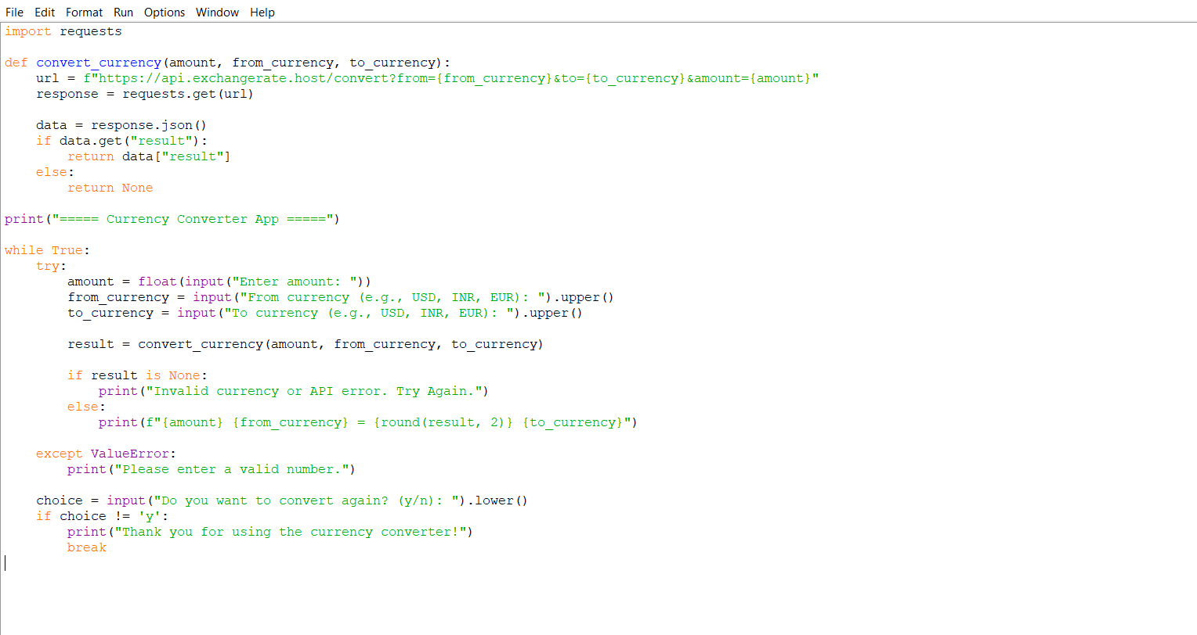

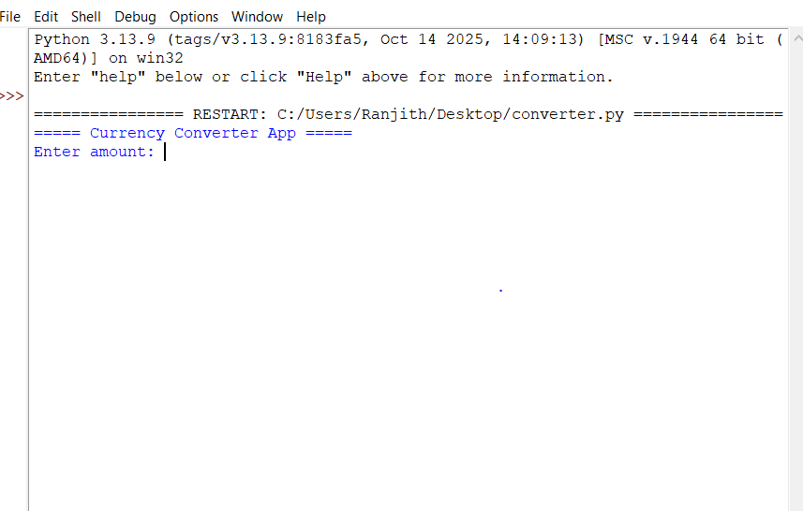

IMPLEMENTATION:
In developing this Currency Converter application, I chose Python as the base programming language because it is easy, flexible, and provides excellent support for APIs. Also, I put the entire project logic into a single Python script file so that its execution would be quite simple for beginners. The program starts by importing the requests library that permits communication of my code with the online API to fetch real-time exchange rates.

The implementation first contains a function convert_currency(). I built this function so that the conversion process is handled separately from the rest of the program. Inside this function, I created a URL link that contains the base currency, target currency, and amount entered by the user. Then, with the help of the requests.get() method, the program sends a request to the API and receives the conversion data in JSON format. Having obtained the JSON response, the program extracts the converted value and returns it to the main program.

In order to make the program interactive, I included a loop in the main section of the code. This loop prompts the user to insert the amount, base currency, and target currency. Once values are introduced, the convert_currency() function is invoked, printing the converted result on the screen. After each conversion, the program asks the user if they want to continue with more currency conversions or to quit. If a user enters "no", that stops the loop from running and ends the program.

I also implemented proper error handling to make the program more stable. If the user enters an invalid currency code, if the API fails to respond, or if the internet connection is not available, instead of crashing, it shows an error message. It ensures smooth execution and good user experience. The overall implementation throughout combines the user inputs, API communication, calculation, and result display efficiently and in a structured way.

CHALLENGES FACED:
In this Currency Converter project, there were quite a few problems that came up during the development that helped improve my learning. Understanding how an API works and how to take out data from its JSON response was very hard to comprehend in the beginning. Error handling was another challenge because the program would just stop when wrong currency codes were entered, or when the internet failed. I also struggled with debugging small mistakes like indentation and logical errors in Python. Putting together the user input, API requests, calculations, and output seamlessly took some time, but all of these obstacles overcome made the project more reliable and improved my confidence in Python.

LEARNING AND KEYTAKEAWAYS:
Throughout this project on the Currency Converter, I have learned many important concepts that helped enhance my programming skills. I learned how Python communicates with external APIs and fetches data in real time; this helped me reach a place of understanding regarding how modern applications work on live information. Important principles like writing clean code, using functions to separate logics, were learned, making the program more comprehensible. Error handling was another major takeaway wherein I came to understand the ways of managing invalid input, avoiding crashes in a program. Over all, this project taught me problem-solving, debugging, and developing an application user-friendly in Python.

FUTURE ENHANCEMENT:
Although the current version of the Currency Converter performs real-time currency conversion effectively, there are several improvements that can be added in the future to make the project more advanced and user-friendly. A graphical user interface (GUI) using Tkinter or a web interface could be introduced so that users do not need to type inputs manually. Another enhancement could be adding a feature to display historical exchange rates and currency trends over time. Storing recent conversions and creating a transaction history would also improve usability. Multi-language support and voice-based input can make the application accessible to more users. Additionally, integrating multiple exchange-rate APIs will increase reliability, ensuring the program continues working even if one API fails. These enhancements can make the application more powerful and suitable for practical day-to-day use.

REFERENCES

ExchangeRate API Documentation — for accessing real-time currency conversion data.
https://exchangerate.host

Python Official Documentation — for understanding functions, JSON handling, and requests.
https://docs.python.org

